
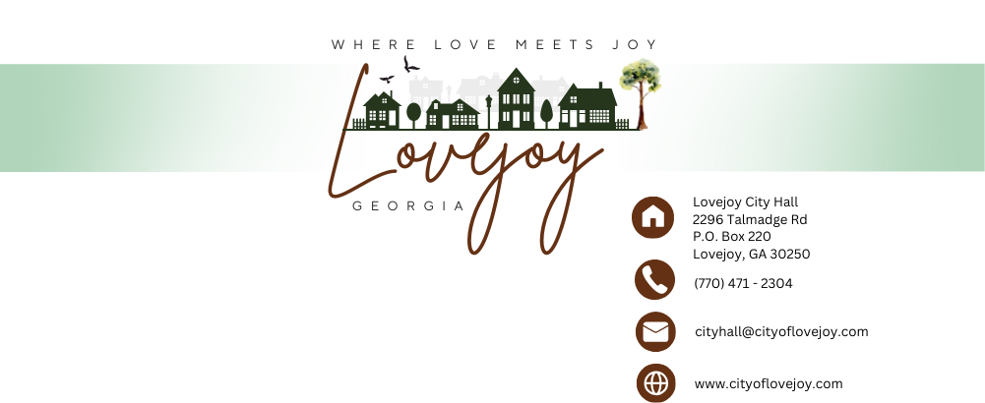

LOVEJOY DEVELOPMENT AUTHORITY
2296 Talmadge Road
Lovejoy, GA 30250
Monday, September 15, 2025
5:30 PM

Jermaine Moore Rosannette Kirby
Chair Vice Chair

Jerome Samuel Danny Harrison
Board Member Board Member

Olene Rackard Victor Davis
Board Member Board Member

- Call to order
- Approval of agenda w/ additions or deletions
- Approval of Meeting Minutes
- Executive Director’s Update
- Financial Director’s Update
- Adjourn

Next Meeting
Monday, December 15, 2025

Individuals with disabilities who require certain accommodations in order to allow them to observe and/or participate in this meeting, or who have questions regarding the accessibility of the meeting or the facilities are required to contact City Hall at 770-471-2304 as soon as practically possible before the meeting to allow the City to make reasonable accommodations for those persons.

